**SIGNALS AND SYSTEMS LAB**

**List of Experiments**

1. Generation of Various Signals such as Unit Impulse, Unit Step, Sinusoidal, Ramp.
2. Operations on Signals such as Addition, Multiplication, Scaling, Shifting, Folding.
3. Finding the Even and Odd parts, Real and Imaginary parts of Signal.
4. Convolution of signals.
5. Autocorrelation and cross correlation of signals.
6. Verification of linearity and time invariance properties of a given continuous/discrete system.
7. Fourier Transform and Inverse Fourier Transform.
8. Laplace Transform of standard signals.
9. Z-transform and pole-zero map plotting.
10. Sampling theorem verification.
11. Gibbs Phenomenon.
12. Computation of unit samples, unit step and sinusoidal response of the given LTI system and verifying its physical realiazability and stability properties.

SIMULATION RESULT:

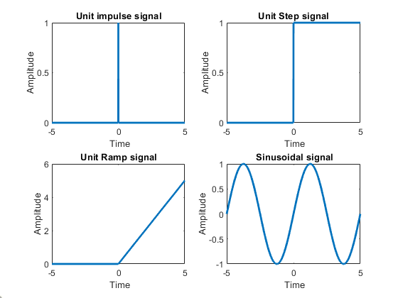

Expt No: Date:

# Generation of Various Signals such as Unit Impulse, Unit Step, Unit Ramp and Sinusoidal.

**AIM:**  To generate Basic signals like Unit Impulse, Unit Step, Unit Ramp and Sinusoidal using MATLAB

**TOOLS REQUIRED**:

MATLAB Software,

Personal Computer.

# MATLAB CODE:

%BASIC SIGNAL GENERATION

% Generation of Unit Impulse, Step, and Ramp & Sinusoidal Signals

clc;

clear;

close all;

%Generation of Unit Impulse Signal

t =-5:0.01:5;

[m,n] = size(t);

Imp = zeros(m,n);

Step = zeros(m,n);

Ramp = zeros(m,n);

for i = 1:n

if t(i) == 0

Imp(i) = 1;

else

Imp(i) = 0;

end

%Generation of Unit Step Signal

if t(i) >= 0

Step(i) = 1;

else

Step(i) = 0;

end

%Generation of Ramp Signal

if t(i) >= 0

Ramp(i) = t(i);

else

Ramp(i) = 0;

end

end

% Generation of Sinusoidal Signal

f=0.2;

y=sin(2*pi*f*t);

subplot(221);plot(t,Imp);xlabel(' Time');ylabel('Amplitude');title('Unit impulse signal');

subplot(222);plot(t,Step);xlabel(' Time');ylabel('Amplitude');title('Unit Step signal');

subplot(223);plot(t,Ramp);xlabel(' Time');ylabel('Amplitude');title('Unit Ramp signal');

subplot(224);plot(t,y);xlabel(' Time');ylabel('Amplitude');title(' Sinusoidal signal');

##### RESULT:

Expt No: Date:

# 2.Operations on Signals such as Addition, Multiplication, Scaling, Shifting, Folding

**AIM:**  To perform Operations on Signals such as Addition, Multiplication, Scaling, Shifting, Folding using MATLAB.

**TOOLS REQUIRED**:

MATLAB Software,

Personal Computer.

**a. Addition and Multiplication of signals.**

# MATLAB CODE:

%Operations on signals

% Addition and Multiplication of signals

clc;

clear;

close all;

%Generation of sinusoidal Signals

t =-25:0.01:25;

f1=0.2;

x=sin(2*pi*f1*t);

f2=0.1

y=sin(2*pi*f2*t);

subplot(411);plot(t,x,'linewidth',2);xlabel(' Time');ylabel('Amplitude');title(' Sinusoidal signal1');

subplot(412);plot(t,y,'linewidth',2);xlabel(' Time');ylabel('Amplitude');title(' Sinusoidal signal2');

%Addition of sinusoidal Signal

z=x+y;

subplot(413);plot(t,z,'linewidth',2);xlabel(' Time');ylabel('Amplitude');title(' Addition of Sinusoidal signals');

%Multiplication of sinusoidal Signal

w=x.*y;

subplot(414);plot(t,w,'linewidth',2);xlabel(' Time');ylabel('Amplitude');title(' Multiplication of Sinusoidal signals');

SIMULATION RESULT:

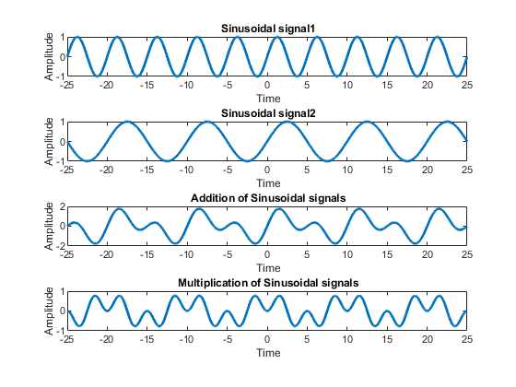

**b. Scaling, Shifting and Folding of signals**

# MATLAB CODE:

clc;

clear all;

close all;

%Generation of sinusoidal Signals

t =-25:0.01:25;

f=0.2;

x=sin(2*pi*f*t);

z=2*x;

y=sin(4*2*pi*f*t);

w=flip(x);

subplot(411);plot(t,x,'linewidth',2);xlabel(' Time');ylabel('Amplitude');title(' Original Sinusoidal signal');

subplot(412);plot(t,z,'linewidth',2);xlabel(' Time');ylabel('Amplitude');title(' Ammplitude Scaling');

subplot(413);plot(t,y,'linewidth',2);xlabel(' Time');ylabel('Amplitude');title(' Time Scaling');

subplot(414);plot(t,w,'linewidth',2);xlabel(' Time');ylabel('Amplitude');title(' Time Revarsal');

SIMULATION RESULT:

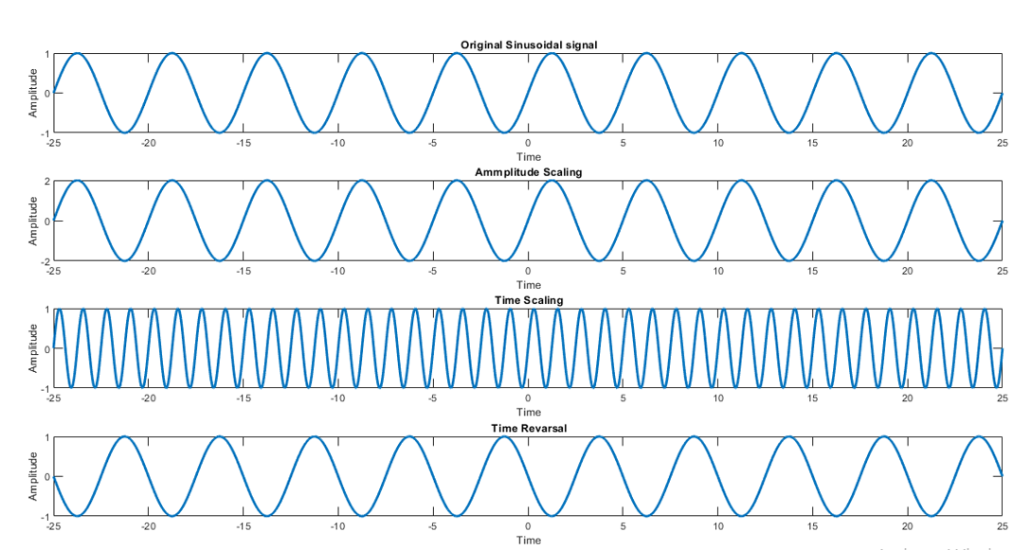

Expt No: Date:

# 3. Finding the even and odd parts, real and imaginary parts of the signal

**AIM:**  To find the even and odd parts, real and imaginary parts of the signal using MATLAB.

**TOOLS REQUIRED**:

MATLAB Software,

Personal Computer.

# MATLAB CODE:

clc;

clear all;

close all;

t = 0:0.01:1;

f =5; %Operating frequency

p=sin (2*pi*f*t); %Odd signal

q=cos(2*pi*f*t); %Even signal

r=p+q; % Combined signal

r_fold=fliplr(r); % Folded signal

even_sig=0.5*(r+r_fold); % Reconstructed even signal

odd_sig=0.5*(r-r_fold); % Reconstructed odd signal

subplot(3,2,1);

plot(t,p);

title('Original Odd signal');

subplot(3,2,2);

plot(t,q);

title('Original even signal');

subplot(3,2,3);

plot(t,r);

title('Combined signal');

subplot(3,2,4);

plot(t,r_fold);

title('combined signal(folded)');

subplot(3,2,5);

plot(t,even_sig);

title('reconstructed even signal');

subplot(3,2,6);

plot(t,odd_sig);

axis([0 1 -1 1]);

title('reconstructed Odd signal');

figure(2);

plot(t,real(odd_sig));

title('Real part of odd signal');

figure(3);

plot(t,imag(odd_sig));

title('Imaginary part of odd signal');

figure(4);

plot(t,real(even_sig));

title('Real part of even signal');

figure(5);

plot(t,imag(even_sig));

title('Imaginary part of even signal');

SIMULATION RESULT:



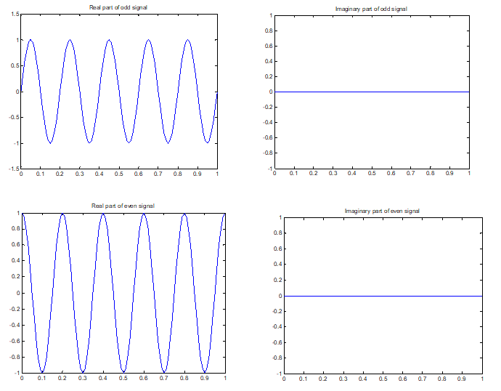

Expt No: Date:

# 4. Convolution of signals.

**AIM:**  To find convolution of given signals using MATLAB.

**TOOLS REQUIRED**:

MATLAB Software,

Personal Computer.

**MATLAB CODE:**

clc;

clear all;

close all;

x=input('enter input sequence');

h=input('enter impulse response');

y=conv(x,h);

subplot(3,1,1);

stem(x);

xlabel('n');

ylabel('x(n)');

title('input signal')

subplot(3,1,2);

stem(h);

xlabel('n');

ylabel('h(n)');

title('impulse response')

subplot(3,1,3);

stem(y);

xlabel('n');

ylabel('y(n)');

title('linear convolution')

disp('The resultant signal is');

disp(y)

**INTPUT:**

enter input sequence[1 4 3 2]

enter impulse response[1 0 2 1]

The resultant signal is

1 4 5 11 10 7 2

**OUTPUT:**

SIMULATION RESULT:

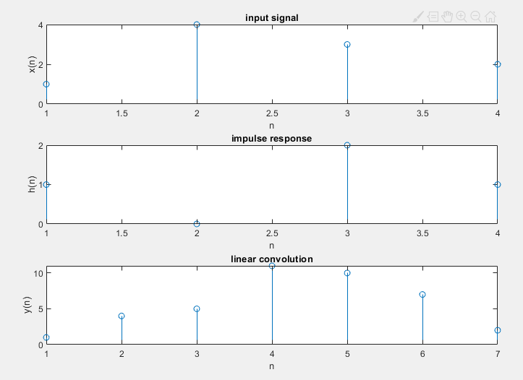

Expt No: Date:

# 7. Fourier Transform and Inverse Fourier Transform of signals

**AIM:**  To find Fourier Transform and Inverse Fourier Transform of given signals using MATLAB.

**TOOLS REQUIRED**:

MATLAB Software,

Personal Computer.

**a. Fourier Transform of given signal**

**MATLAB CODE:**

clc;

clear all;

close all;

syms x t

x=exp(-5*t)*heaviside(t);

% x=input(‘enter any signal’);

% x=dirac(t);

y=fourier(x);

display(y);

%magnitude spectrum

mag=abs(y)

ezplot(mag,[-10 10]);

%title('Magnitude spectrum');

**Output:**

y =1/(5 + w*1i)

**b. Inverse Fourier Transform of given signal**

clc;

clear all;

close all;

syms w X a

X=sin(w);

% x=2/abs(w);

% X=2/(i*w);

% X=input('Enter the signal');

y=ifourier(X);

display(y);

**Output:**

If X=sin(w)

y =(dirac(x - 1)*1i)/2 - (dirac(x + 1)*1i)/2

If X=2/(i*w)

y = sign(x)

SIMULATION RESULT:

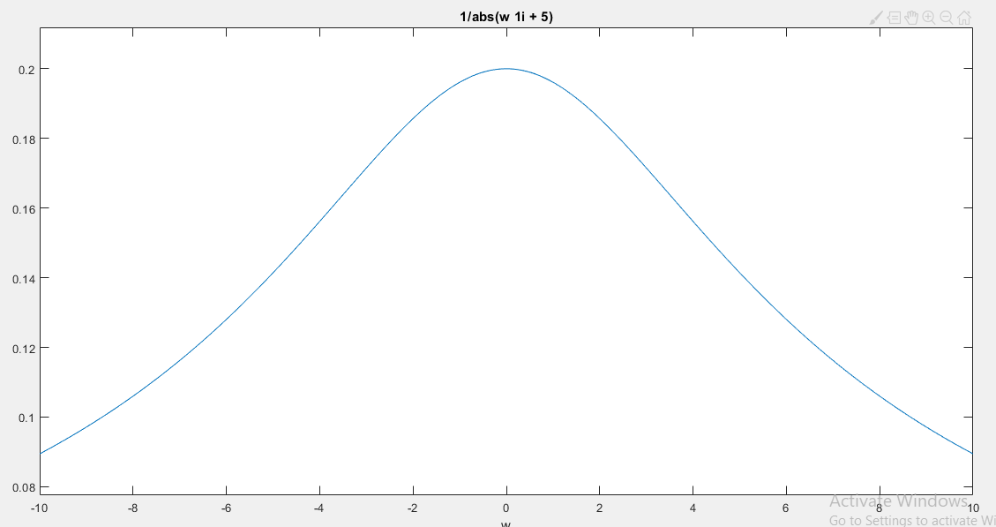

Expt No: Date:

# 8. Laplace Transform of standard signals

**AIM:**  To find Laplace Transform of given signals using MATLAB.

**TOOLS REQUIRED**:

MATLAB Software,

Personal Computer.

**a. Laplace Transform of given signal**

**MATLAB CODE:**

clc;

clear all;

close all;

syms x t

x=exp(-5*t)*heaviside(t);

%x=input(‘enter any signal’);

y=laplace(x);

display(y);

%magnitude spectrum

mag=abs(y)

ezplot(mag,[-10 10]);

%title('Magnitude spectrum');

**Output:**

y =1/(s + 5)

mag =1/abs(s + 5)

SIMULATION RESULT:

